
Company
Logotype

Cone Beam Computed Tomography- Report



Porur Dental X-rays & CBCT

Patient Name : Mr. Saravanan | Date of Report : 24.04.2024
Age/ Gender : 45 years/ Male | Region of Interest : CBCT Sectional Maxilla
Referring doctor: Dr. Balamurali Sai | Indication : Nil
Clinical Notes: Nil
PATIENT INFORMATION

CBCT- Sectional Maxilla provided
CBCT – IMAGE DETAILS

RADIOGRAPHIC INTERPRETATION

- Presence of hyperdense screw like structures (dental implant) in relation to 12, 13 region.
- The alveolar bone in relation to the placed implants are present with normal trabecular pattern.
- The tooth 11 is present with hyperdense restorative material within the pulp canal extending upto the apical third of the root.
- The implant in relation to 13 is present at a distance of 4.49 mm from the floor of the nasal cavity.
- The implant in relation to 12 is present at a distance of 6.12 mm from the floor of the nasal cavity.
 | 14 region
Sub-Crestal (in mm) | 7.38
Mid- Crestal (in mm) | 8.34
Distance between the alveolar ridge and floor of the maxillary sinus (in mm) | 8.53
Distance between the alveolar ridge and floor of the nasal cavity  (in mm) | 9.42
Distance between 15 and the implant in 13 region (in mm) | 7.66

RADIOGRAPHIC IMPRESSION

- Dental implants in relation to 12, 13 region.
- Root canal treated : 11
- Implant assessment done in relation to 14 region.

Kindly correlate with clinical findings


IMAGES FOR REFERENCE

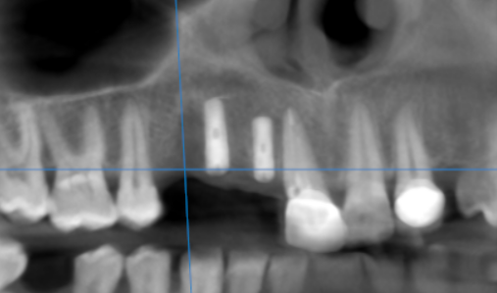

3-DIMENSIONAL VIEW

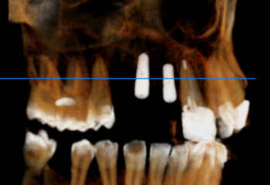

CROSS SECTIONAL VIEW
12 region | 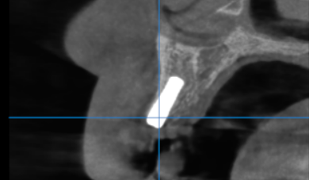
13 region | 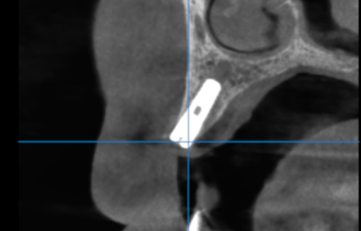
14 region | 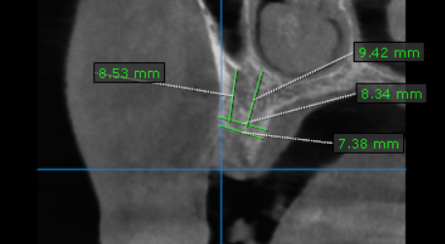

**** End of report ****

